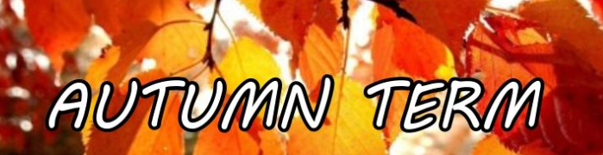

Our Topic is ‘All About Me’

During this half term we will be learning:

|  |  |  |
| --- | --- | --- |
| Maths  We will explore the numbers from 0 – 5.  We will learn how to count with 1:1 correspondence and we will be introduced to the numerals too.  We will also be learning the names of 2D shapes. We will also learn which 3D shapes stack and which shapes roll. | Phonics  We will be learning Set 1 sounds during our Phonics lessons.  The order of these sounds will be placed inside your child’s bag. | Literacy  We will be reading the stories:  Peace at Last by Jill Murphy  Owl Babies by Martin Waddell  Goldilocks and the three bears by Tim Budgen  We will learn to retell these stories and we will learn some tier 2 vocabulary from these stories too. |
| Foundations of Science  (Understanding of the World)  We will be learning about our 5 senses. We will use our 5 senses to explore different areas of provision in our setting. | All About Me - Scrapbook Page Title Sticker | Scrapbook pages ... | Foundations of Geography  (Understanding of the World)  We will be learning about our local area. We will use Google Earth to look at some places around Swallownest. |
| Foundations of PSHE  (PSED)  We will be learning about our family. We will share photos of our family with our friends and we will draw our family in provision.  We will also paint ourselves in our craft station. | Foundations of Design and Technology (Expressive Arts)  We will learn about different types of joins. We will explore these in provision. Then, we will create our own join by making an envelope for a card or a box for a present. | Fine and Gross motor  To support our gross and fine motor we will be doing dough disco challenges daily.  We will learn to roll, splat, pinch and squeeze our play dough. |

Thank you for all of your continued support. Please check Seesaw on a regular basis. We upload learning and experiences weekly.