**Quick Recall Facts**

Year 6 - Summer

By the end of this half term, children should know the following facts.

1. **I know the size of angles in triangles, on a straight line, the rules for vertically opposite angles and interior angles of a polygon.**

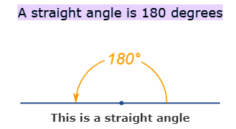

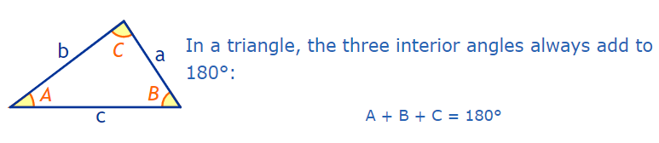

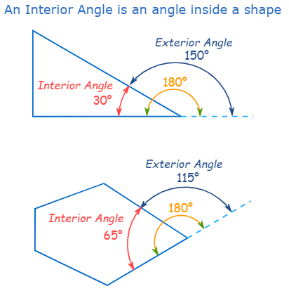

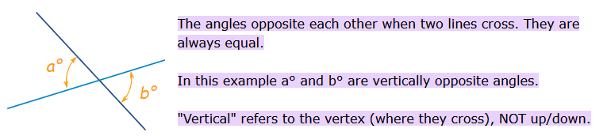

**Top Tips**

The secret is practising little and often. You don’t need to practise these all at once, perhaps you could have a fact of the day. Can you practice these Quick Recall Facts during a car journey?

* Create a maths glossary for all of your new terminology/new knowledge – include pictures, key numbers and key words.
* Use this handy online tool for angles in a triangle practice <https://www.transum.org/software/SW/Starter_of_the_day/Students/AnglesInTriangle/Quiz.asp>
* Draw some patterns on paper including triangles, straight lines, polygons on straight lines and crossing lines where there are vertically opposite angles. Label some of the missing ones with numbers and ask your child to figure out the others.