**Quick Recall Facts**

Year 3 – Spring

By the end of this term, children should know these following facts. The aim is for them to know these facts instantly.

1. **I know my 4 and 8 times tables.**

4 x 1 = 4

4 x 2 = 8

4 x 3 = 12

4 x 4 = 16

4 x 5 = 20

4 x 6 = 24

4 x 7 = 28

4 x 8 = 32

4 x 9 = 36

4 x 10 = 40

4 x 11 = 44

4 x 12 = 48

4 ÷ 4 = 1

8 ÷ 4 = 2

12 ÷ 4 = 3

16 ÷ 4 = 4

20 ÷ 4 = 5

24 ÷ 4 = 6

28 ÷ 4 = 7

32 ÷ 4 = 8

36 ÷ 4 = 9

40 ÷ 4 = 10

44 ÷ 4 = 11

48 ÷ 4 = 12

8 x 1 = 8

8 x 2 = 16

8 x 3 = 24

8 x 4 = 32

8 x 5 = 40

8 x 6 = 48

8 x 7 = 56

8 x 8 = 64

8 x 9 = 72

8 x 10 = 80

8 x 11 = 88

8 x 12 = 96

8 ÷ 8 = 1

16 ÷ 8 = 2

24 ÷ 8 = 3

32 ÷ 8 = 4

40 ÷ 8 = 5

48 ÷ 8 = 6

56 ÷ 8 = 7

64 ÷ 8 = 8

72 ÷ 8 = 9

80 ÷ 8 = 10

88 ÷ 8 = 11

96 ÷ 8 = 12

**Key Vocabulary**

What is 4 **multiplied by** 6?

What is 8 **times** 4?

What is 24 **divided by** 4?

**How many groups of** 4 in 48?

**How many groups of** 8 in 64?

**Top Tips**

The secret is practising little and often. You don’t need to practise these all at once, perhaps you could have a fact of the day. Can you practice these Quick Recall Facts while walking to school?

* Online – Go to <https://www.topmarks.co.uk> for super bowling maths multiplication and Tommy’s Trek

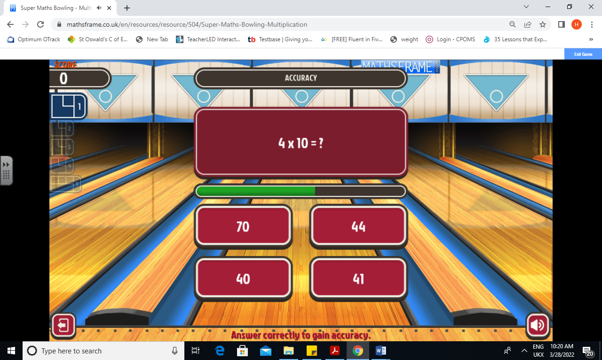 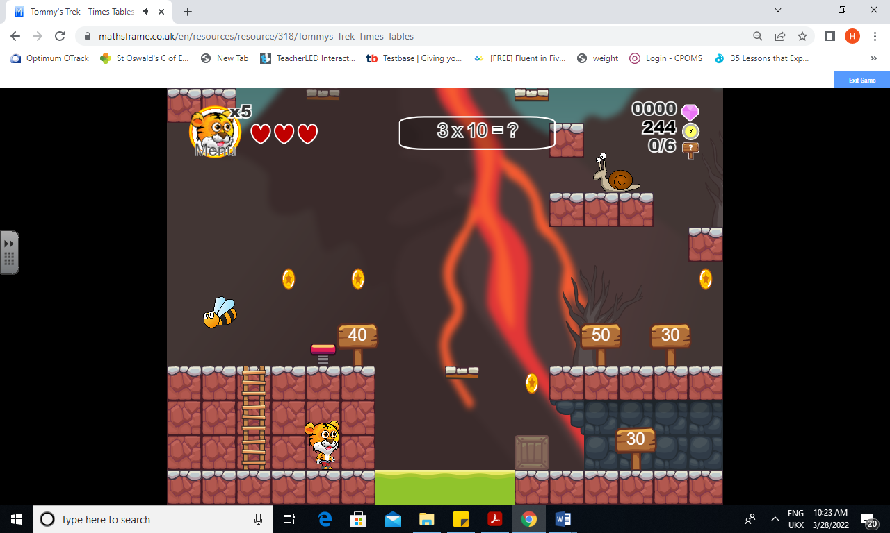

* Songs and Chants – You can buy Times Tables CDs or find multiplication songs and chants online. If your child creates their own song, this can make the times tables even more memorable.
* Double your fours –Multiplying a number by 8 is the same as multiply by 4 and then doubling the answer. 8 × 4 = 32 and double 32 is 64, so 8 × 8= 64.
* Five six seven eight–fifty-six is seven times eight (56 = 7 × 8).