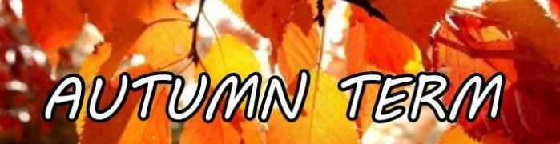

Our Topic is ‘Celebrations’
During this half term we will be learning:

Maths  We will begin by comparing the sizes of different objects using the language bigger, smaller, little and the positional vocabulary such as in, out, under, on, in front, behind.  We will then move onto accurate counting up to 3, using our ‘fast eyes’ to subitise and instantly recognise an amount of objects, then count then carefully. | Phonics  We follow the Read, Write, Inc Phonics programme.  Each day, we will complete a different listening game, to encourage the children to ‘tune in’ to a wide range of sounds and volumes.  In some games, the children will need to respond to a sound by moving their bodies or copying a repeated sound. For some games, we will practice our ‘Fred talk’, by segmenting the sounds in words to sound them out, for example b-u-g = bug | English  This term, we will read and focus on the texts Hansel and Gretel, The Gingerbread Man and The Nativity Story.  We like to use the areas on continuous provision in the classroom to practice retelling these stories, such as in the Role Play area and the Small World area as well all challenges in the Construction, Sand, Water and Fine Motor areas throughout the term.
Understanding of the World  We will focus on different celebrations that are part of the children’s lives, such as Diwali, Hallowe’en, Bonfire Night and Christmas. We will talk about how different families celebrate these events in different ways.  We will use our senses to learn about how materials can change. This includes using play dough, melting chocolate and melting ice!  We will be learning about the Nativity Story, which will help us to prepare for our performance in the Christmas concert with the F2 children! |  | PSED  We will be celebrating our differences and what makes us special. We will be talking about what makes a kind friend.
 | Expressive Arts  We have a different focus each week in our Workshop area, alongside the continuous provision of collage materials and box modelling. We love seeing the interesting models the children can create!  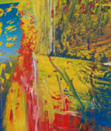  We will be looking at the work of Gerhard Richter, who creates beautiful artwork using a lot of colourful lines!  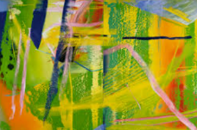 | Physical Development  Every day, we complete an activity to strengthen our fine motor and gross motor skills, using some funky music to help us!  We are challenged through cutting activities each week, with a focus on handling scissors safely and developing good pencil grip and control.  We complete PE sessions each week- this term we are focusing on balancing!

Thank you all for your continued support! If you would like to speak about any of these learning opportunities or how you can support your child at home, please speak to Mrs Leivers and Mrs Chan.

