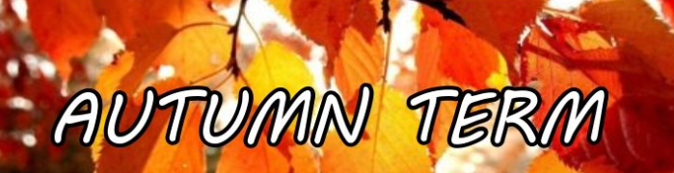

Our Topic is ‘All About Me’

During this half term we will be learning:

|  |  |  |
| --- | --- | --- |
| Maths  We will explore the numbers from 0 – 5.  We will learn how to count with 1:1 correspondence and we will be introduced to the numerals too.  We will also be learning the vocabulary more, less, big, medium and small. | Phonics  We will be learning to develop our speaking and listening skills, laying the groundworks for Phonics work.  We will be listening to environmental sounds and instrumental sounds.  We will also be learning to find the Rhyme. | English  We will be learning the story Goldilocks and the three bears and The Little Red Riding Hood. We will learn the vocabulary from the stories.  We will learn to retell the stories using phrases or full sentences. We will use our creative skills to draw or craft some of the characters from the stories. |
| Foundations of Science  (Understanding of the world)  We will be learning about our body. We will learn about parts of our body. We will also learn how our body changes, We will explore our similarities and differences | We will be reading Goldilocks and the three bears. | Foundations of Geography  (Understanding of the world)  We will be learning about our local area. We will use Google Earth to look at some places around Swallownest. A home learning challenge is to go on a local walk with your family. |
| Foundations of PSHE  (PSED)  We will be learning about our family. We will share photos of our family with our friends and we will draw our family in provision.  We will also paint ourselves in our craft station. | We will also be reading ‘Red Riding Hood. | Fine and Gross motor  To support our gross and fine motor we will be doing dough disco challenges on a regular basis.  We will learn to roll, splat, pinch and squeeze our play dough. |

Thank you for all of your continued support. Please check Seesaw on a regular basis. We upload learning and experiences weekly.