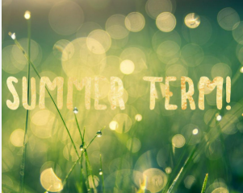

Our topic this term is ‘People Who Help Us’

During this half term we will be learning:
Maths  We will learn to count to 5 using concrete objects. We will use counters to help count on, and then begin to count back.  We will explore subitising and begin to recognise the number of objects in a group without having to count them individually.  We will continue to explore both 2D and 3D shapes. | Phonics  In school, we follow the Read, Write, Inc Phonics programme. Each day, we will complete a different listening game, to encourage the children to ‘tune in’ to a wide range of sounds and volumes.  In some games, the children will need to respond to a sound by moving their bodies or copying a repeated sound. For some games, we will practice our ‘Fred Talk’, by segmenting the sounds in words to sound them out, for example b-u-g = bug | Literacy  We will be reading the stories The Gruffalo and The Three Billy Goats Gruff.  We will learn new vocabulary and retell these stories.  We will explore drawing and writing marks for characters in the story, as well as continuing to work on recognising and tracing our names.  We like to use the areas in the classroom to practice retelling these stories, such as in the Role Play area and the Small World area as well all challenges in the Construction, Sand, Water and Fine Motor areas throughout the term.
Understanding the World: Foundations of Science  We will learn about plants and the children will be able to identify a plant and understand it is a living thing. Will learn about what a plant needs to survive  e.g. water, light, food. | 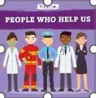 | Understanding the World: Foundations of History  We will be learning about our own living history, by exploring memories we have and recount these to our friends.  We will be asking for a photograph of a special memory to be shared via Seesaw so that the children can share these with the class.
Physical Development: Foundations of Physical Education  Every day, we complete an activity to strengthen our fine motor and gross motor skills, using some funky music to help us!  We are challenged through cutting activities each week, with a focus on handling scissors safely and developing good pencil grip and control.  We complete PE sessions each week- this term we are focusing on ball skills | Our Topic this halt term is People Who Help Us. We are excited to learn about different people who work in roles to help us in our community | Expressive Art and Design: Foundations of Art  We will be learning about the Artist Andy Goldsworthy, who created beautiful outdoor sculptures and structures. We will explore the different styles of art and have a go at creating our own art work inspired by Andy Goldsworthy.

Thank you all for your continued support! If you would like to speak about any of these learning opportunities or how you can support your child at home, please speak to Mrs Leivers and Mrs Chan.

