**Science at Swallownest Primary School**

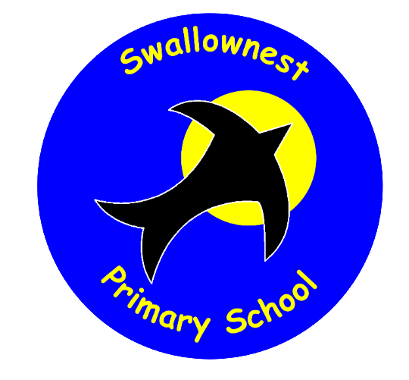

*We want the best for and the best from everyone in our learning community*

**Intent**

The 2014 national curriculum for Science aims to ensure that all pupils:

* develop scientific knowledge and conceptual understanding through the specific disciplines of biology, chemistry and physics
* develop understanding of the nature, processes and methods of science through different types of science enquiries that help them to answer scientific questions about the world around them
* are equipped with the Disciplinary Knowledge and scientific skills required to understand the uses and implications of science, today and for the future. We understand that it is important for lessons to have a skills-based focus, and that the knowledge can be taught through this.

At Swallownest Primary School, we believe that all pupils are scientists: we encourage children to be inquisitive throughout their time at the school and beyond. The Science curriculum fosters a healthy curiosity in children about our universe and promotes respect for the living and non-living. We believe science encompasses the acquisition of knowledge, concepts, skills and positive attitudes. Although not all of our pupils will go on to become scientists, all of our pupils will develop a reflective and critical mindset.

Throughout the programmes of study, the children will acquire and develop the Key Knowledge that has been identified within each unit and across each year group, as well as the application of scientific skills (the Disciplinary Knowledge). We ensure that this Disciplinary Knowledge is developed throughout children’s time at the school so that they can apply their knowledge of science when using equipment, conducting experiments, building arguments and explaining concepts confidently while continuing to ask questions and be curious about their surroundings and the wider world.

**Implementation**

**Teaching and Learning**

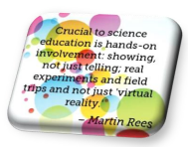At Swallownest Primary, we teach Science discretely through weekly Science lessons. We believe that good science teaching builds progressively on pupils existing ideas, and in order for effective delivery of science education across a series of lessons, there should develop opportunities for:

* Finding out children’s ideas, conceptions and misconceptions using a variety of elicitation opportunities
* Analysing children’s ideas
* Providing opportunities for testing ideas, thereby possibly changing them
* Providing opportunities for developing process skills so that testing is scientific and accurate
* A ‘hands on’ approach to finding the answers to our scientific questions and queries

The Programme of Study for Science describes a sequence of knowledge and concepts. While it is important that pupils make progress, it is also vitally important that they develop secure understanding of each key block of knowledge and concepts in order to progress to the next stage. Children’s starting points are identified at the beginning of each science topic and the children are able to convey and record what they know already. At the end of the block, children’s knowledge is checked in line with the key knowledge identified prior to the teaching block.

Pupils should be able to describe associated processes and key characteristics in common language, but they should also be familiar with technical terminology and use this accurately and precisely. They should build up an extended specialist vocabulary and teachers ensure that this is developed within each lesson and throughout each science topic.

At Swallownest Primary School, we believe that Science teaching and learning is good when;

* We apply our Disciplinary Knowledge to solve problems, explore, observe and investigate
* We ask questions and work together to discover the answers
* Science has a wow factor and promotes a sense of awe and wonder
* We are involved in creating and carrying out investigations and can share and explain our ideas and conclusions
* 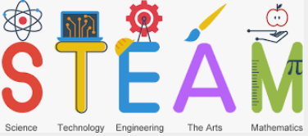We are able to apply our mathematical knowledge to our understanding of Science, including collecting, presenting and analyzing data

**Key Substantive Knowledge**

Our curriculum has been carefully designed so that pupils gain more knowledge over time.

We know that knowledge ‘sticks’ when links are made between subjects. Webs of knowledge are created in our memories (schema) when we create meaningful links between learning. The more we introduce pupils to related content, the deeper knowledge will be.

At the start of each unit, Key Knowledge curriculum documents outline the intentions for teaching and learning, including Key Knowledge (which are taken from the Programme of Study for Science).

Key scientific vocabulary has been identified, as well as Key Enquiries which will be a focus for each stage and unit of working. This Key Knowledge is regularly returned to during Retrieval Practise so that this will ‘stick’ in children’s memory. At key points throughout the year, the class teacher encourages children to retrieve knowledge taught in previous years. In Foundation stage, the children retrieve knowledge from the previous term.

In the Foundation Stage, Science content is delivered through the ‘Understanding of the World’ strand of the EYFS curriculum. This involves guiding children to make sense of their physical world and their community through opportunities to explore, observe and find out about people, places, technology and the environment. They are assessed according to the Development Matters attainment targets. Key Knowledge and Key Enquiries have been identified for focus in Foundation 1 and Foundation 2.

As children progress through school, they develop their science skills in the disciplines of Biology, Physics and Chemistry through the following Units of Work:

|  |  |  |
| --- | --- | --- |
| **Biology** | **Physics** | **Chemistry** |

|  |  |  |  |  |  |  |  |  |  |  |  |
| --- | --- | --- | --- | --- | --- | --- | --- | --- | --- | --- | --- |
| EYFS | Ourselves | | Identifying and Classifying Materials | | Plants | | | Weather and Seasonal Changes | | | |
| Year 1 | Seasonal Changes | Classifying and Grouping Materials | | Animals including Humans | | | All Living Things- Plants | | | Light | |
| Year 2 | Sound | Uses of Everyday Materials | | All Living Things | | Animals including Humans | | Light (non-statutory) | | | All Living Things- Plants |
| Year 3 | Rocks and Fossils | Changing, Classifying and Grouping Materials | | Animals including Humans | | Light | | Forces and Magnets | | | All Living Things- Plants |
| Year 4 | Sound | Animals including Humans | | All Living Things | | Electricity | | | States of Matter | | |
| Year 5 | Forces and Motion | Magnetism | | Properties and Changes of Materials | | Animals, Including Humans | | All Living Things-Plants | | | Earth and Space |
| Year 6 | Animals, including Humans | Evolution and Inheritance | | Light | | All Living Things | | | Electricity | | |

**Key Disciplinary Knowledge**

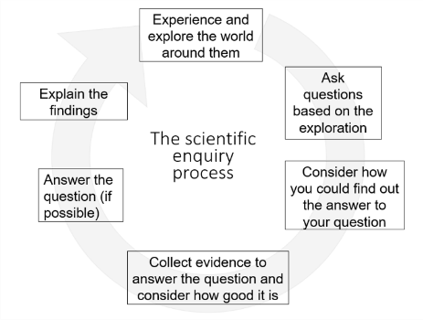Disciplinary Knowledge is embedded into lessons to ensure these skills are being developed throughout the children’s school career and new vocabulary and challenging concepts are introduced through direct teaching. This is developed through the years, and is evident on the Key Coverage document. Throughout our curriculum, children are engaged in asking questions and using one of the five types of scientific enquiry:

* observation over time
* fair or comparative tests
* identification and classification
* research
* pattern seeking

Teachers demonstrate how to use scientific equipment, and the various strands of Disciplinary Knowledge in order to embed scientific understanding. Teachers find opportunities to develop children’s understanding of their surroundings by accessing outdoor learning and workshops with experts when possible, drawing on members of the community as well as professionals.

**Teacher Subject Knowledge**

At Swallownest Primary School, we use the resources available through Reach Out CPD for staff to develop their own personal subject knowledge around the areas of the Programme of Study that will be taught. The Subject Leader accesses and has lead CPD sessions in the Local Authority, and delivers regular CPD sessions with staff in school.

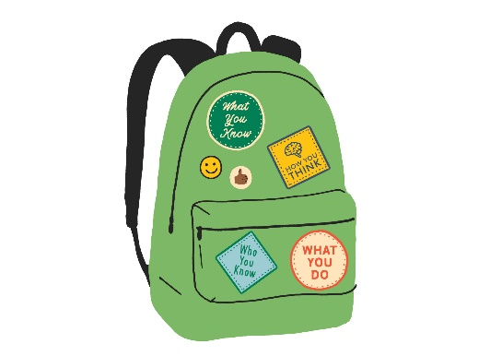**Science Capital**

Everything a pupil does and thinks in science is important, so it is crucial that sessions provide regular opportunities for pupils to engage in hands on practical activity as well as think about or research scientific ideas and developments. All of these aspects come together to develop a child’s Science Capital, which we work to develop throughout each child’s time at Swallownest Primary School.

We draw focus on Scientific developments and news through regular discussion, which further develops our learners’ ability to reason and reflect on their own understanding of the world.

We consider the work of a Key Scientist during each Unit of Work, which enables pupils to gain understanding of a wide range of scientific disciplines, and who the trailblazers of these disciplines are. We have a focus on BAME and female scientists, with a view of proving that Science is accessible and achievable for all children, from all backgrounds.



*Shine a Light on inclusive Science teaching and learning 2022*

Teachers create a positive attitude to science learning and reinforce an expectation that all pupils are capable of achieving high standards in science. Our whole school approach to the teaching and learning of science involves the following;

* Through our planning, we involve problem solving opportunities that allow children to apply their knowledge, and find out answers for themselves
* Children are encouraged to ask their own questions and will be given opportunities to use their scientific skills and research to discover the answers. This curiosity is celebrated within the classroom and throughout the school.
* Teachers use precise questioning and regular retrieval practise in class to test conceptual knowledge and skills, and assess pupils regularly to identify those children with gaps in learning, so that all pupils continue to make progress.
* We build upon the knowledge learned across school by forging horizontal, vertical and diagonal links across subjects, Science Units and year groups. As the children’s knowledge and understanding increases, and they become more proficient in selecting, using scientific equipment, collating and interpreting results, they become increasingly confident in their growing ability to come to conclusions based on real evidence.
* We forge strong links with other subjects, such as Geography, History and English, as well as other key STEAM subjects. We focus on a Key Text to drive our Science Units of work, such as a picture book in the EYFS, or a text for discussion in KS1 and KS2, in order to discuss the prior knowledge and any misconceptions the children may have.
* Children are offered a range of extra-curricular activities, visits, trips and visitors to complement and broaden the curriculum. These are purposeful and link with the knowledge being taught in class throughout the school year.
* Regular events, such as Science Week, provide broader provision and the acquisition and application of knowledge and skills. These events often involve families and the wider community, including making links to local secondary schools and Sheffield Hallam University.

**Impact**

Children at Swallownest Primary School enjoy science and this results in motivated learners with sound scientific understanding.

The approach at Swallownest Primary results in an engaging, high-quality science education, that provides children with the foundations and knowledge for understanding the world.

Our engagement with the local environment ensures that children learn through varied and first hand experiences of the world around them. Frequent, continuous and progressive learning outside the classroom is embedded throughout the science curriculum.

Through trips and interactions with experts and studying Key Scientists, children have the understanding that science has changed our lives and that it is vital to the world’s future prosperity. Children learn the possibilities for careers in science, which ensures that children have access to positive role models within the field of science from the immediate and wider local community. From this exposure to a range of different scientists from various backgrounds, all children feel they are scientists and capable of achieving.

**Progress of pupils**

How do we consider progress when we are thinking about science?

We focus on two aspects:

* As children know and remember more across the curriculum area, they are making progress
* When children learn what we have intended them to learn (curriculum intent).

When we assess pupils’ progress, we talk to them about what they know and together we look in Floor Books to see what they can do and remember. This includes discussion around the Substantive Knowledge and the Disciplinary Knowledge outline in the Key Knowledge curriculum documents. Subject Leaders and teaching staff check to make sure this matches the curriculum we have implemented.

We assess at all stages of the learning process:

* Assessment for learning: assessing as we teach by observing and questioning to inform next steps needed for each pupil.
* Assessment as learning: using some of these ongoing assessment strategies to consolidate learning and help children deepen knowledge in long term memory (for example, regular retrieval practise, low-stake quizzes, asking children to mind-map everything they have just learned about a concept) will help us find out what they know, where the gaps are to inform future teaching but will also help children remember more in the future as knowledge will become increasingly sticky when using strategies such as these.
* Assessment of learning: Capturing at key end points precisely what children have remembered over time (we called this summative assessment).

In Swallownest Primary School, we aim to meet the needs of all our children by differentiation in our science planning and in providing a variety of scaffolding approaches and tasks appropriate to challenge a range of ability levels. This will enable children with learning and/or physical difficulties to take an active part in scientific learning and practical activities and investigations and to achieve the goals they have been set. Some children will require closer supervision and more adult support to allow them to progress whilst higher attaining children will be extended through further challenge. By being given enhancing and enriching activities, children will be able to progress to a higher level of knowledge and understanding appropriate to their ability. Teachers will use the school’s inclusion strategies to ensure that a range of scaffolds and support are used, which include and motivate all learners, ensuring that optimum progress is made throughout each part of the lesson.